**vi command:**

vi command is used as text editor. vi command can also be used for opening and closing files.

Here after entering the below command, file named **honey** will be opened in the current working directory.

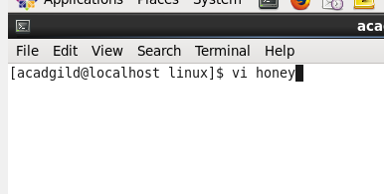

Press ENTER. After pressing ENTER, type the data that you want to save into the file named **honey.**

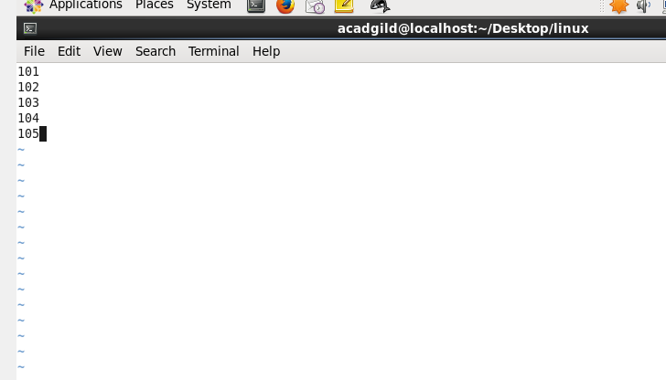

Press Esc key and press “ZZ” to save the data.

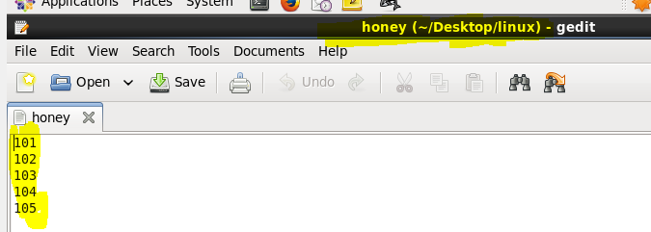

The command named vi has two basic modes:

1. **Command mode:-**

Command mode is the default mode when a file is opened. All file opens initially in command mode, you cannot immediately begin typing text.

1. **Insert mode:-**

 It is used for entering text into the buffer memory. In this mode everything that is typed on the keyboard is added to the text and does not become a command